Project Title

Hotel Management System

1. Abstract

This Hotel Management System, built with Java (NetBeans) and MySQL, provides an efficient solution for managing hotel room operations. The system features real-time room tracking with details like room number, type, price, and status. Administrators can easily add new rooms with automatic validation and instant database updates. Designed with a user-friendly Swing interface and secure JDBC connectivity, it offers a reliable foundation for small to medium hotels. The system is easily expandable for additional functionalities like bookings, staff management, and billing.

2. Introduction

This Hotel Management System is a Java-based desktop application designed to streamline room operations for small hotels. Developed with NetBeans IDE and MySQL, it provides an intuitive interface for staff to manage room inventory efficiently. The system displays real-time room status (available/occupied/maintenance) with key details like pricing and room type

- Technologies Used

  - Programming (Java)

  - Backend (MySQL)

  - IDE (NetBeans)

  - Communication (Socket (TCP))

  - Architecture (Client-Server)

- Features

  - Add/Edit/Delete Rooms

  - Guest Details (name, phone, ID)

  - Bill Generation (room price)

  - Update Room Status (Available/Occupied/Maintenance)

- Project Description

Modules:

- DB.java: Establishes and manages secure MySQL database connections for the Hotel Management System using JDBC.

- RoomManagement.java: Handles the display, addition, and management of hotel rooms through a Swing GUI while syncing with the MySQL database

- GuestCheckIn.java: Handles guest registration, check-in/check-out processes, and updates room status in the database.

- MainMenu.java: Provides the main navigation interface with buttons to access all system modules (Rooms, Guests, Bookings, etc.)

- Code:

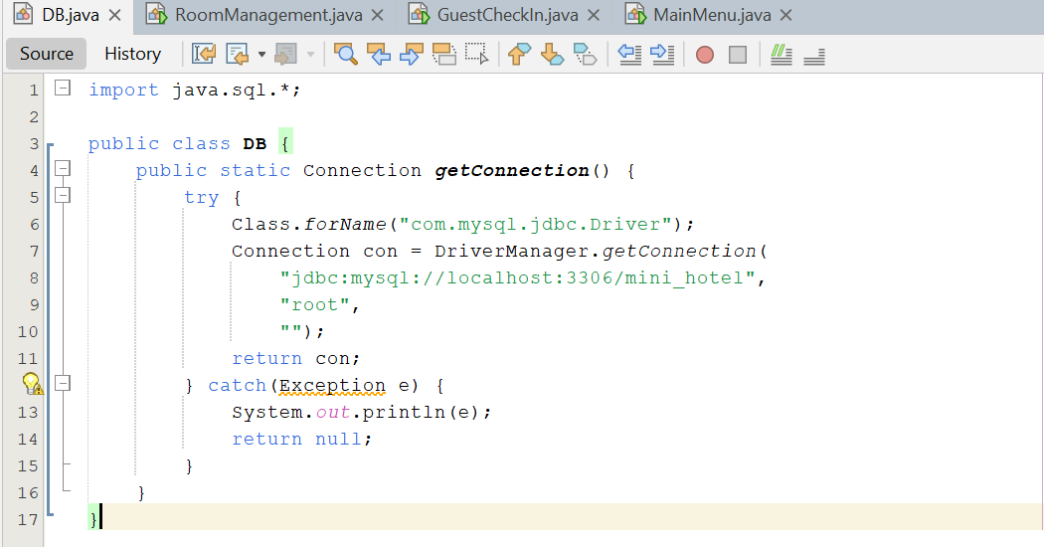
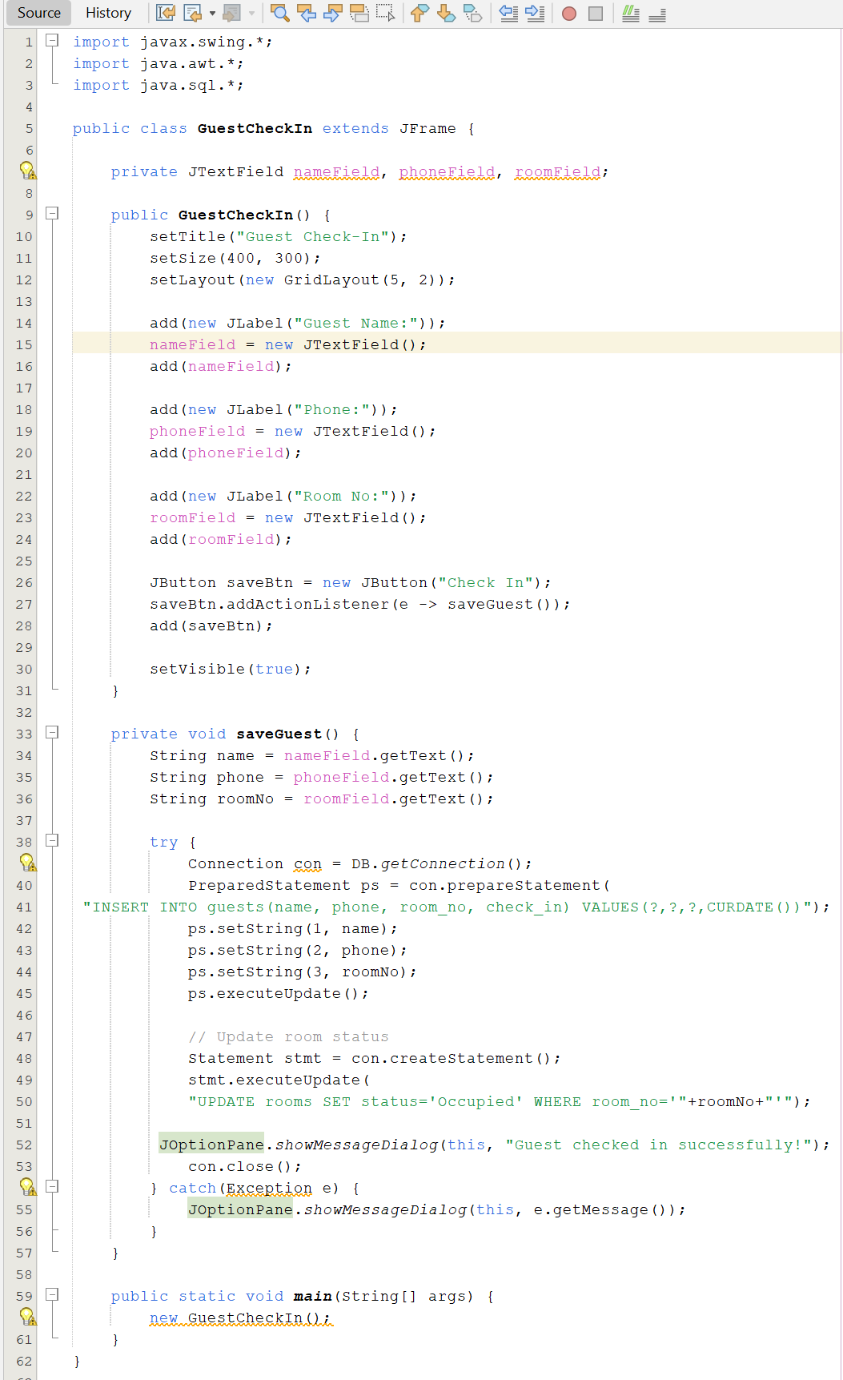
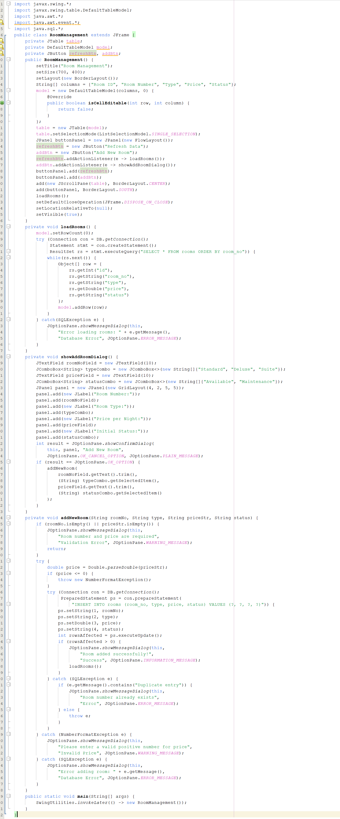

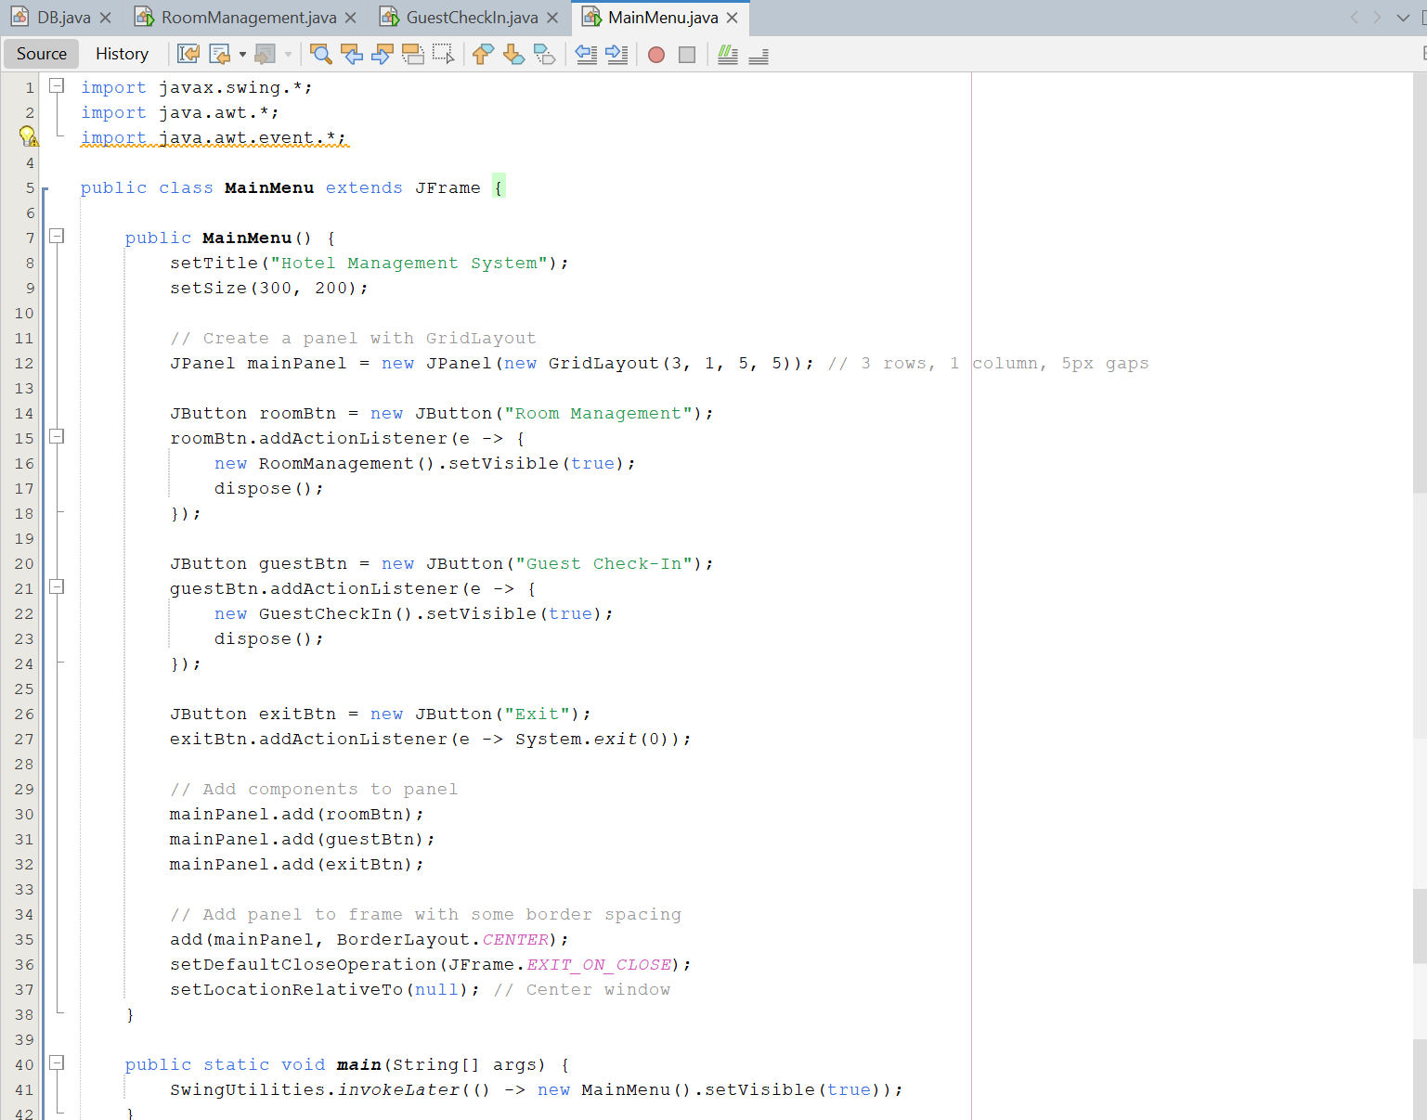

7 . Output:
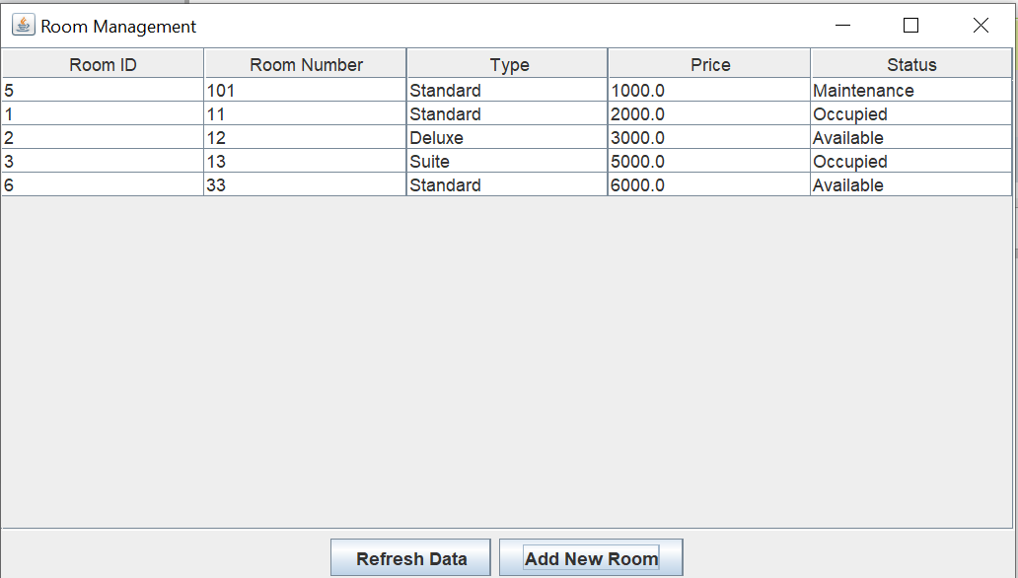
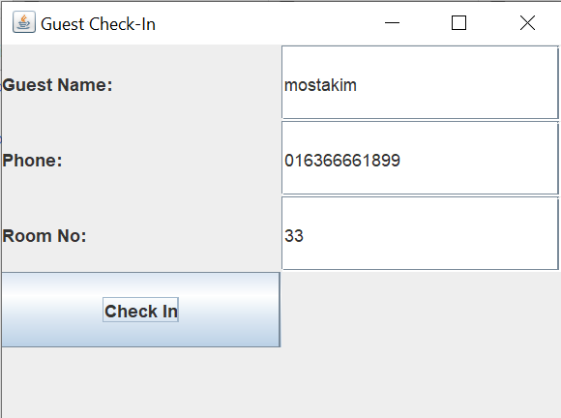
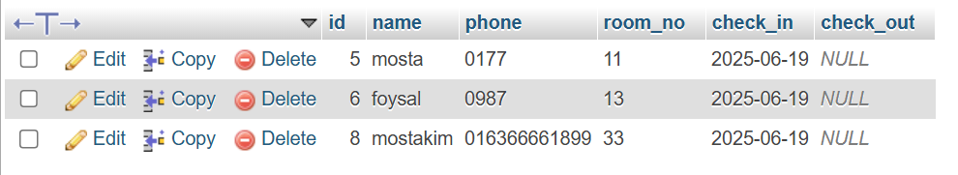

8. Conclusion:

This Hotel Management System project delivers a complete digital solution using Java (Swing), MySQL, and TCP sockets. It automates and streamlines hotel operations through room booking, guest management, and real-time updates. The modular design allows easy addition of new features (e.g., payment gateway, SMS alerts). With built-in security (JDBC Prepared Statements) and a user-friendly interface, it’s an ideal solution for small and mid-sized hotels. Future upgrades could include Android apps or cloud integration for enhanced scalability.

